Public Consultation Questions—Green Project for Yarnfield
(Close of consultation 6th October 2020)
1. | Do you agree with the aim of the project?
2. | How would you rank the proposals? ( 1—6; with 1 being your first priority and 6 your last priority )
 | New approach to grass cutting leaving areas for wildflowers and insects
 | Community orchard—native trees including fruit and nuts.
 | Improvements to the drainage of the Village Green
 | Community garden
 | Nature trails
 | Bat and bird boxes
3. | Are there any other ideas you would like to see incorporated?
4. | If you want to be kept informed about the project please provide a contact email address.

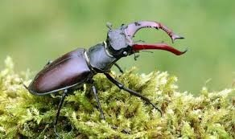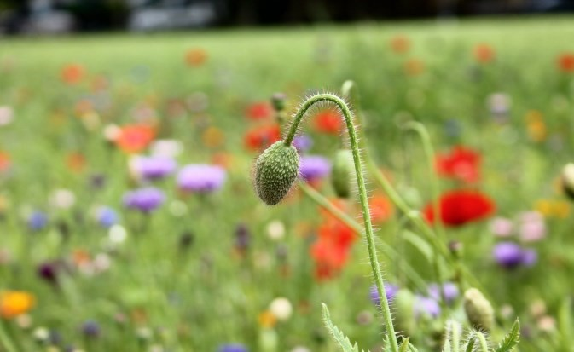

Please return to the Parish Clerk by 6 October 2020:
Email: ycmclerk@gmail.com
Text: 07546456771
To: 5 De Havilland Drive, Yarnfield
Please complete the public consultation questionnaire and return to the Parish Clerk by 6 October 2020:
Email ycmclerk@gmail.com
Text: 07546456771

